

For Immediate Release

**Verstappen celebrates 50th F1 Grand Prix win in the United States**

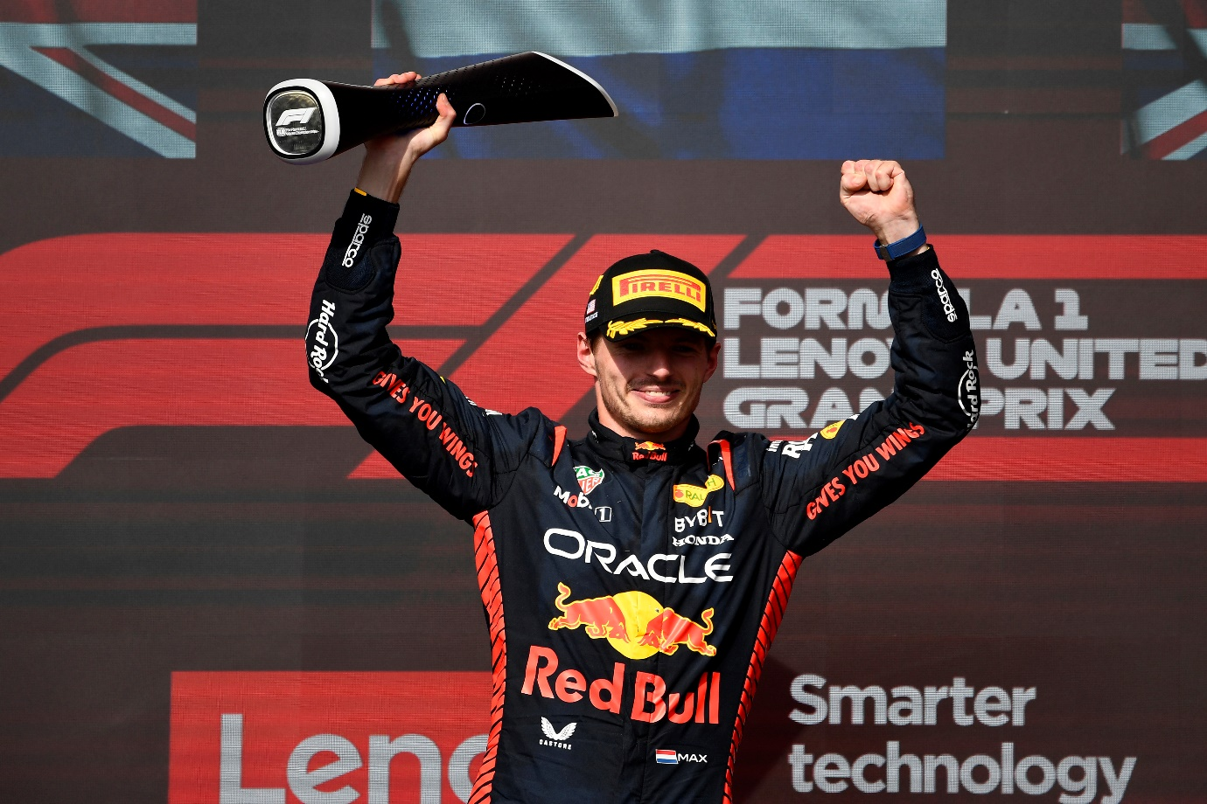

**Circuit of The Americas: 22nd October:** Round 19 of the season, United States Grand Prix took place at Circuit Of The Americas. Max Verstappen of Oracle Red Bull Racing, supported by Honda as a Team Partner, won the race. Sergio Perez of the same team finished 4th.

Oracle Red Bull Racing's Max Verstappen reached a milestone 50 Formula One Grand Prix wins with the victory on Sunday. The Dutchman drove to glory over Mercedes driver Lewis Hamilton and McLaren’s Lando Norris, whilst team-mate Sergio Pérez rounded out the top five at the Circuit of the Americas.

Starting from sixth place on the grid after having his fastest lap deleted for exceeding track limits during Friday’s Q3 session, Verstappen was chasing his third straight win at the Circuit of the Americas after wins at the Texas venue in 2021 and 2022.

Despite the difficult start position and a brake problem that affected the Dutchman from the very first lap of the 56-lap race, Verstappen drove with absolute precision to claim victory, despite a late charge from Hamilton that saw him finish just 2.225s adrift at the chequered flag. Verstappen was clear that the brake issues made this one of his toughest races of the year, however the 2023 world champion managed the situation masterfully to secure his 15th race win of the season from 18 Grands Prix.

Verstappen has now already equalled his record for most wins in an F1 season, set in 2022, and with four Grands Prix still to go he has the chance to extend that record significantly.

After starting ninth on the grid, Sergio Pérez drove a strong race up through the field. His fifth at the finish was later converted into fourth after Hamilton's disqualification and allowed the Mexican to extend his lead over the Brit in the fight for second place in the Drivers’ Championship ahead of his home Grand Prix next weekend.

Points were also scored for Scuderia AlphaTauri in Texas, courtesy of Yuki Tsunoda. The Japanese driver started 11th and battled hard all race to secure 10th place at the finish and score his first points since the Belgian Grand Prix in July, while team-mate Daniel Ricciardo came home in 17th on his return to racing after five Grands Prix on the side-lines with a broken hand.

**Quotes:**

Oracle Red Bull Racing

**MAX VERSTAPPEN - 1st**

"It feels incredible to win my 50th Grand Prix here in Austin. I'm very proud, of course, but I want to keep pushing for more. Starting in P6 today was interesting, I worked my way slowly through to the front. We didn't have a massive pace advantage today and I was struggling with my brakes. I didn't have the same feeling in the car as I did yesterday, so that made the race much tougher than anticipated. You could see it was very close at the end there. We had to rely on the strategy today and the team did a great job with that."

**SERGIO PÉREZ - 5th**

"I wanted more for today, obviously. At times we had really good pace, but we are still lacking that consistency. It was a hard race. The Ferrari seemed to have improved, but I also think we made a good step from yesterday. It was quite difficult to overtake, especially because the exit of Turn 11 was quite tricky, as it was very windy and rough over there. We had a few occasions where we could have undercut people, so I think we need to review that as a team. I think we know what we did wrong across the weekend, so we are really optimistic going into future races. We need to make sure we learn from this weekend as there are some good understandings to make for Mexico. There is a bit more pace in there and I am massively looking forward to my home Grand Prix.”

**CHRISTIAN HORNER - CEO and Team Principal**

Before the race, all our simulations were telling us that the two stop was the fastest race for us and that's what we committed to. The debate was, "do we run the hard in the middle stint or the medium?" We knew going up against Lando Norris that they committed to the two hards, so we felt going medium, medium was the best strategy. It was crucial for Max to make use of that, get the pass, take the track position and then run our fastest race to the end of the race.

"Max was dealing with a brake issue throughout the race, as I’m sure you could hear. It was tough for him and I think his focus was largely on that, although he was able to overcome any issues and bring home the victory. His half century. Another phenomenal achievement for Max.

"Checo also drove well. He’s had some tough races, but he had good pace today and I think he'll take a lot of confidence from that. Hopefully that will put him in a good space before his home race next weekend. As all eyes turn to Mexico, we look forward to seeing what’s to come and what we can achieve.”

**Scuderia AlphaTauri**

**YUKI TSUNODA - 10th**

"It was a good race for me and I'm happy. To score points here three times in a row is amazing, especially in front of the Austin fans. A great job and congratulations to the team. Everyone back at the factory and trackside are working very hard and it’s nice to see that the upgrades they deliver seem to be working well and we’re closing the gap to fight for P10. We got slightly lucky with Fernando (Alonso) in the end, but we maximised the performance, because if we weren’t driving there, we wouldn’t have been able to benefit and score points.

"At first, I got a heart attack when the team called me in to box, because I thought there was an issue, but they told me we were going for the fastest lap on the soft tyre. It was my first experience going for the fastest lap in the final lap of the race and I really enjoyed it, it was thrilling. Now, we’ll refocus and continue to carry this momentum into the final races of this season.”

**DANIEL RICCIARDO - 17th**

"Texas hasn’t been too kind. At the start, we were doing well with our plan, but the problem was once the cars with blue flags came up behind us, we lost too much. We seemed to struggle in traffic and then picked up some damage later on, so after that we lacked pace. On the medium compound, we were doing the same lap times as Yuki, but because I was on a one-stop, there was a bit more tyre management going on for me. Physically, I feel better today than yesterday, so the Sprint race was a good warmup for the Grand Prix. I got more race mileage and there's a lot to learn from this race, so now it’s full attack for Mexico.”

For more information, please visit <https://honda.racing/f1/post/f1-2023-rd19-race>